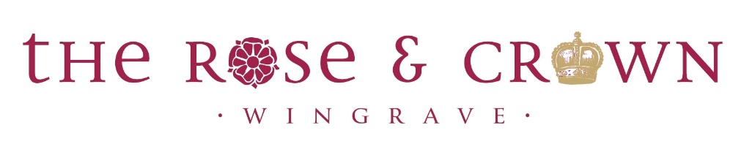

Friday 8th October
‘The Attention Seekers’

Saturday 6th November
‘The Deer, The Mare & The Elephant’

Saturday 4th December
‘G-Elvis’

Saturday 22nd January
‘The Beatin’ Hearts’

BAND NIGHTS

